**Case IH Agriculture Equipment, Inc.**

**For More Information, contact:**

Dan Danford 262/636-7359

[dan.danford@caseih.com](mailto:dan.danford@caseih.com)

**Idaho Farmers Win Case IH Farmall Tractor**

**RACINE, Wis.** (March 20, 2014)

Maintaining its support for young producers who show leadership in the agriculture industry, Case IH awarded nine new Farmall® tractors to the runners-up of the 2014 American Farm Bureau Federation (AFBF) Young Farmers & Ranchers awards. One of those tractors, a Farmall 65A, will go to Dwight and Jamie Little of Newdale, Idaho, for being finalists for the Achievement award.

The winners, announced at the AFBF 95th Annual Meeting Jan. 12-15 in San Antonio, Texas, were selected based on their leadership skills, personal accomplishments and the growth of their operation.

“Case IH is proud to support these outstanding individuals as they continue to pursue a future in the agriculture industry,” says Zach Hetterick, Case IH Livestock Marketing Manager. “At Case IH, we strive to provide the tools and resources to help young producers develop a strong foundation for their future.”

The Littles’ third-generation farming operation started out with orphan calves being bottle-fed. Now the operation includes 1,000 acres of crops and 9,000 acres of pasture for 160 beef cattle.

“Farm Bureau has given me the opportunity to meet a lot of neat people and really good friends,” says Dwight. “It has allowed me to be in closer contact with our legislators and grow our operation through networking and learning from others.”

The Littles ordered their Case IH Farmall 65A from Case IH dealer Pioneer Equipment Co. and said they can’t wait to get the tractor. They plan to use it daily with their potato production.

“I really can’t express my gratitude for Case IH,” says Dwight. “It shows their commitment to agriculture, and I hope to see them continue to do this, as it really encourages participation in the Young Farmers & Ranchers program.”

The couple first got involved with Farm Bureau about seven years ago. They both sit on their county board and serve as district chairs for the YF&R program for their state. They remain involved in as many ways as possible.

The Littles are involved with their community’s school board and various other farming organizations in their area. They are also involved with church and community service projects, all while raising a family.

Case IH is a global leader in agricultural equipment, committed to collaborating with its customers to develop the most powerful, productive, reliable equipment – designed to meet today’s agricultural challenges. With headquarters in the United States, Case IH has a network of dealers and distributors that operates in over 160 countries. Case IH provides agricultural equipment systems, flexible financial service offerings and parts and service support for professional farmers and commercial operators through a dedicated network of professional dealers and distributors. Productivity enhancing products include tractors; combines and harvesters; hay and forage equipment; tillage tools; planting and seeding systems; sprayers and applicators; site-specific farming tools and utility vehicles. Case IH is a brand of CNH Industrial N.V. (NYSE: CNHI / MI: CNHI).

###

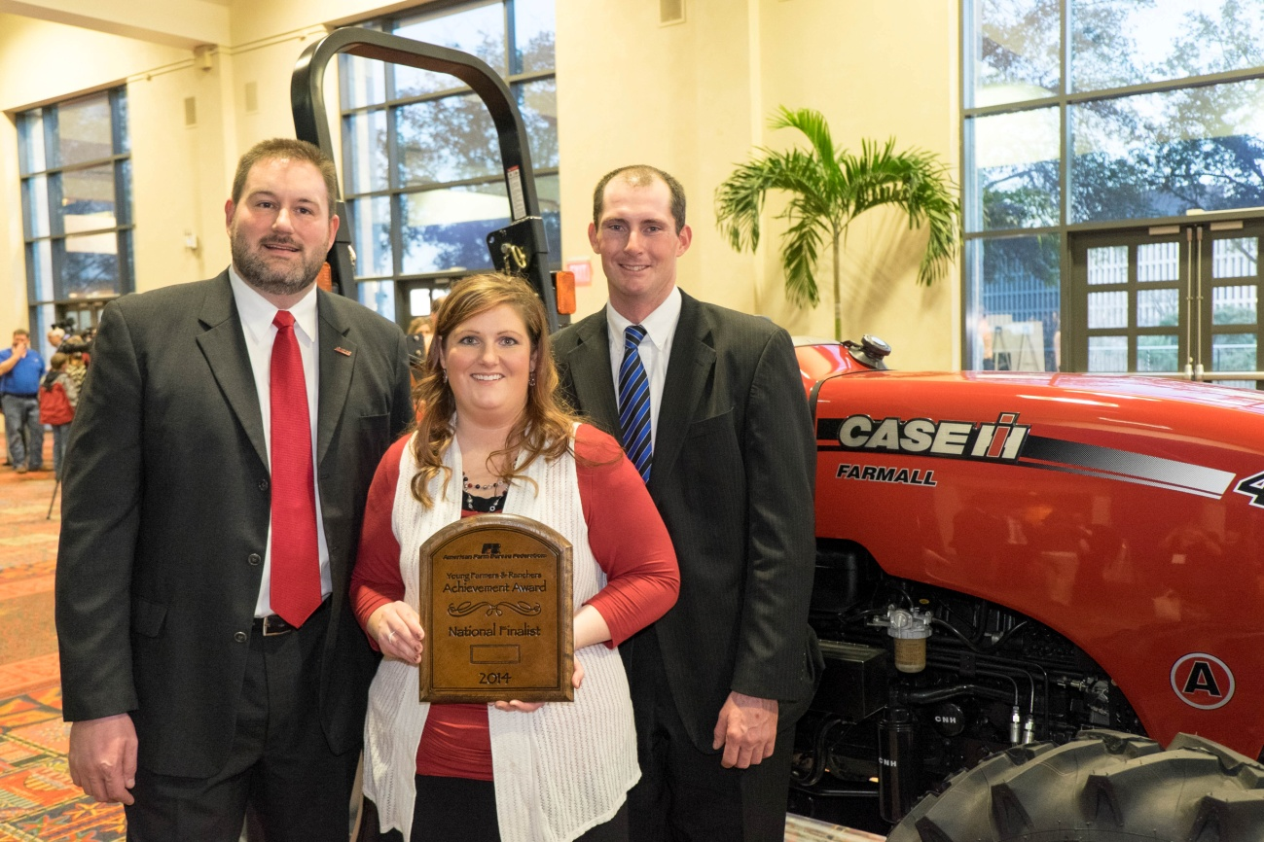

**Photo Caption:** Jamie and Dwight Little, right, were one of this year’s runners-up for the 2014 American Farm Bureau Federation Young Farmers & Ranchers Achievement award and received a Case IH Farmall 65A tractor. They were selected based on their leadership skills, personal accomplishments and the growth of their operation. The couple plans to use the tractor daily for potato production on their farm in Newdale, Idaho.